1. **Creating Source and destination S3 Buckets**

1. Creating IAM Policy

1. Creating IAM Role and assigning it to lambda function

1. Configuring the environment variable

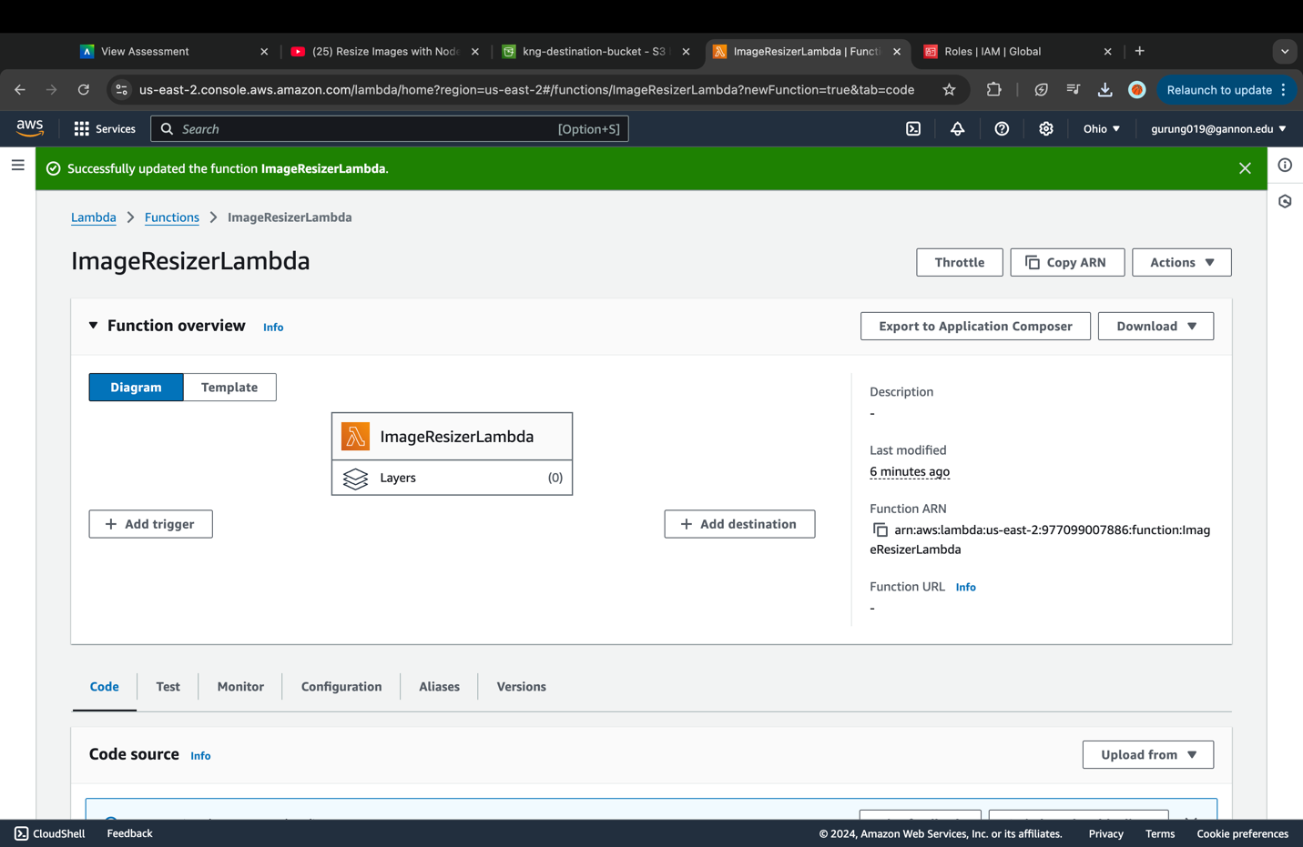

1. Uploading the zip file

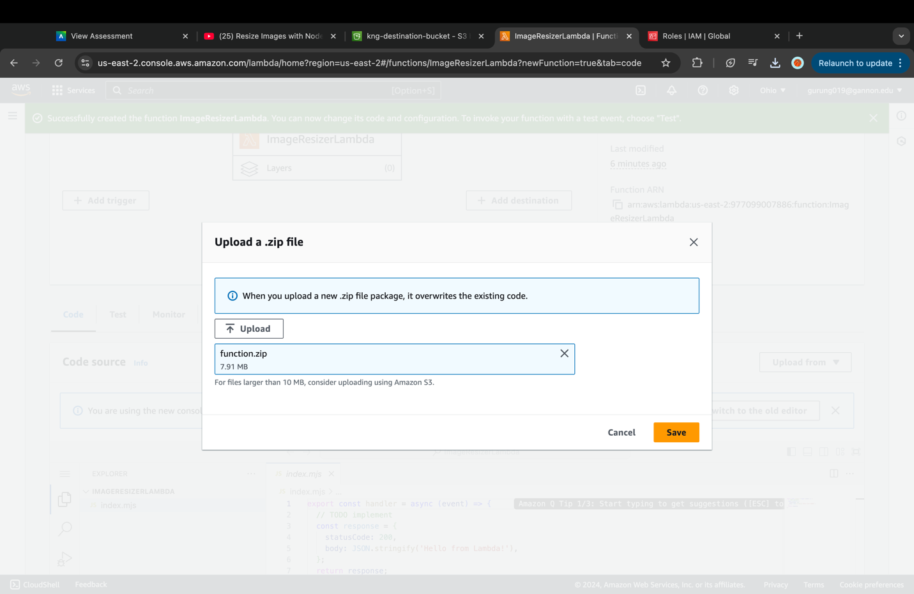

1. Creating a Lambda Trigger

1. Uploading the image file

1. Checking image on the destination folder

1. Cleanup



